Desde tu cliente,crea 2 conexiones TNS para acceder:
- A tu servidor Oracle, utilizando SERVICE NAME. Llámala ORCL.VWIN2003.
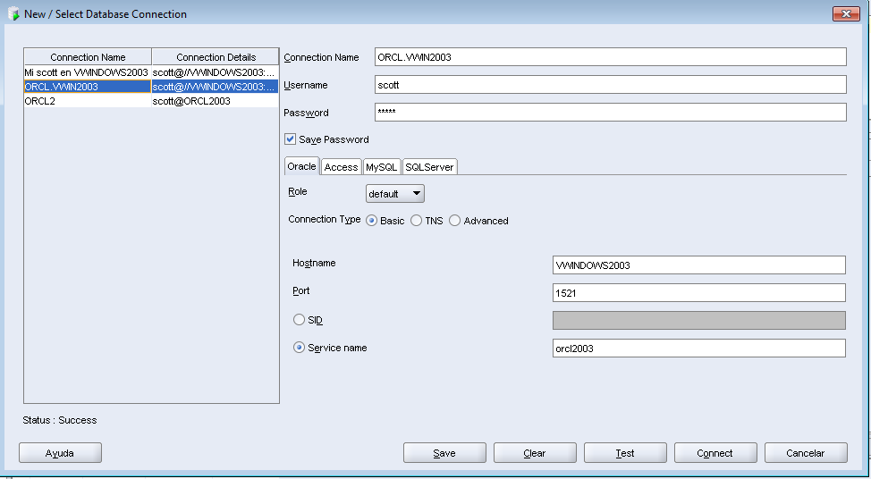
- A tu servidor Oracle, utilizando SID. Llámala ORCL2.VWIN2003.

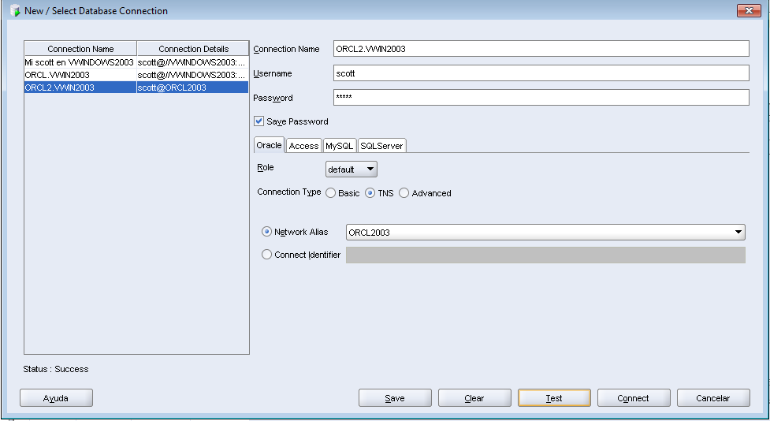

TNSNAMES.ora

ORCL2003 =
(DESCRIPTION =
(ADDRESS_LIST =
(ADDRESS = (PROTOCOL = TCP)(HOST = VWINDOWS2003)(PORT = 1521))
)
(CONNECT_DATA =

(SERVICE_NAME = orcl2003)
)
)

